R Markdown

Dr Josh A Hodge

# Background

RMarkdown is a dynamic document that enables you to develop code and embed it inline in a word file. RMarkdowns are used a lot for reproducible research. You will be required to submit a RMarkdown for your coursework (MSc’s only) as part of the Biological Computing module.

# Writing with Markdown

Headings in an RMarkdown are indicated by using hastags. In the RMarkdown document increasing the number of hashtags will decrease the size of the heading, for example:

# Example of one hastag

###### Example of six hastags

You can also **bold** your text, *italicise*, superscript and subscript.

Other useful things are of course creating number lists like:

1. Number one
2. Number two

Or bullet pointing:

* bullet one

# Inline Coding, Table and Figures

The best feature of RMarkdown is the fact you can include code embedded in your documents, for example:

data("iris") #loading iris dataset

You can include tables of your data:

knitr::kable(head(iris),caption = "First Five Rows of Iris")

First Five Rows of Iris

| Sepal.Length | Sepal.Width | Petal.Length | Petal.Width | Species |
| --- | --- | --- | --- | --- |
| 5.1 | 3.5 | 1.4 | 0.2 | setosa |
| 4.9 | 3.0 | 1.4 | 0.2 | setosa |
| 4.7 | 3.2 | 1.3 | 0.2 | setosa |
| 4.6 | 3.1 | 1.5 | 0.2 | setosa |
| 5.0 | 3.6 | 1.4 | 0.2 | setosa |
| 5.4 | 3.9 | 1.7 | 0.4 | setosa |

And you can create tables without having the code in your document using echo=FALSE in the curly brackets of {r, echo=FALSE}.

First Five Rows of Iris

| Sepal.Length | Sepal.Width | Petal.Length | Petal.Width | Species |
| --- | --- | --- | --- | --- |
| 5.1 | 3.5 | 1.4 | 0.2 | setosa |
| 4.9 | 3.0 | 1.4 | 0.2 | setosa |
| 4.7 | 3.2 | 1.3 | 0.2 | setosa |
| 4.6 | 3.1 | 1.5 | 0.2 | setosa |
| 5.0 | 3.6 | 1.4 | 0.2 | setosa |
| 5.4 | 3.9 | 1.7 | 0.4 | setosa |

With creating figures, you can customised a lot in the {r}, such as:

* Figure alignment: {r, fig.align="center"}, {r, fig.align="left"} or {r, fig.align="right"}
* Figure caption or legend: {r, fig.cap="legend"}
* Figure dimensions: {r, fig.width=inches} and/or {r, fig.height=inches}
* Figure resolution: {r, dpi=} where a higher value of dpi means higher resolution: try 300, 500 or 700.

So let’s make a figure using: {r, fig.align="center", fig.cap="Figure-1: relationship between petal length (cm) and sepal length (cm)", dpi=500}

plot(iris$Petal.Length~iris$Sepal.Length, xlab="Sepal Length (cm)", ylab="Petal Length (cm)")

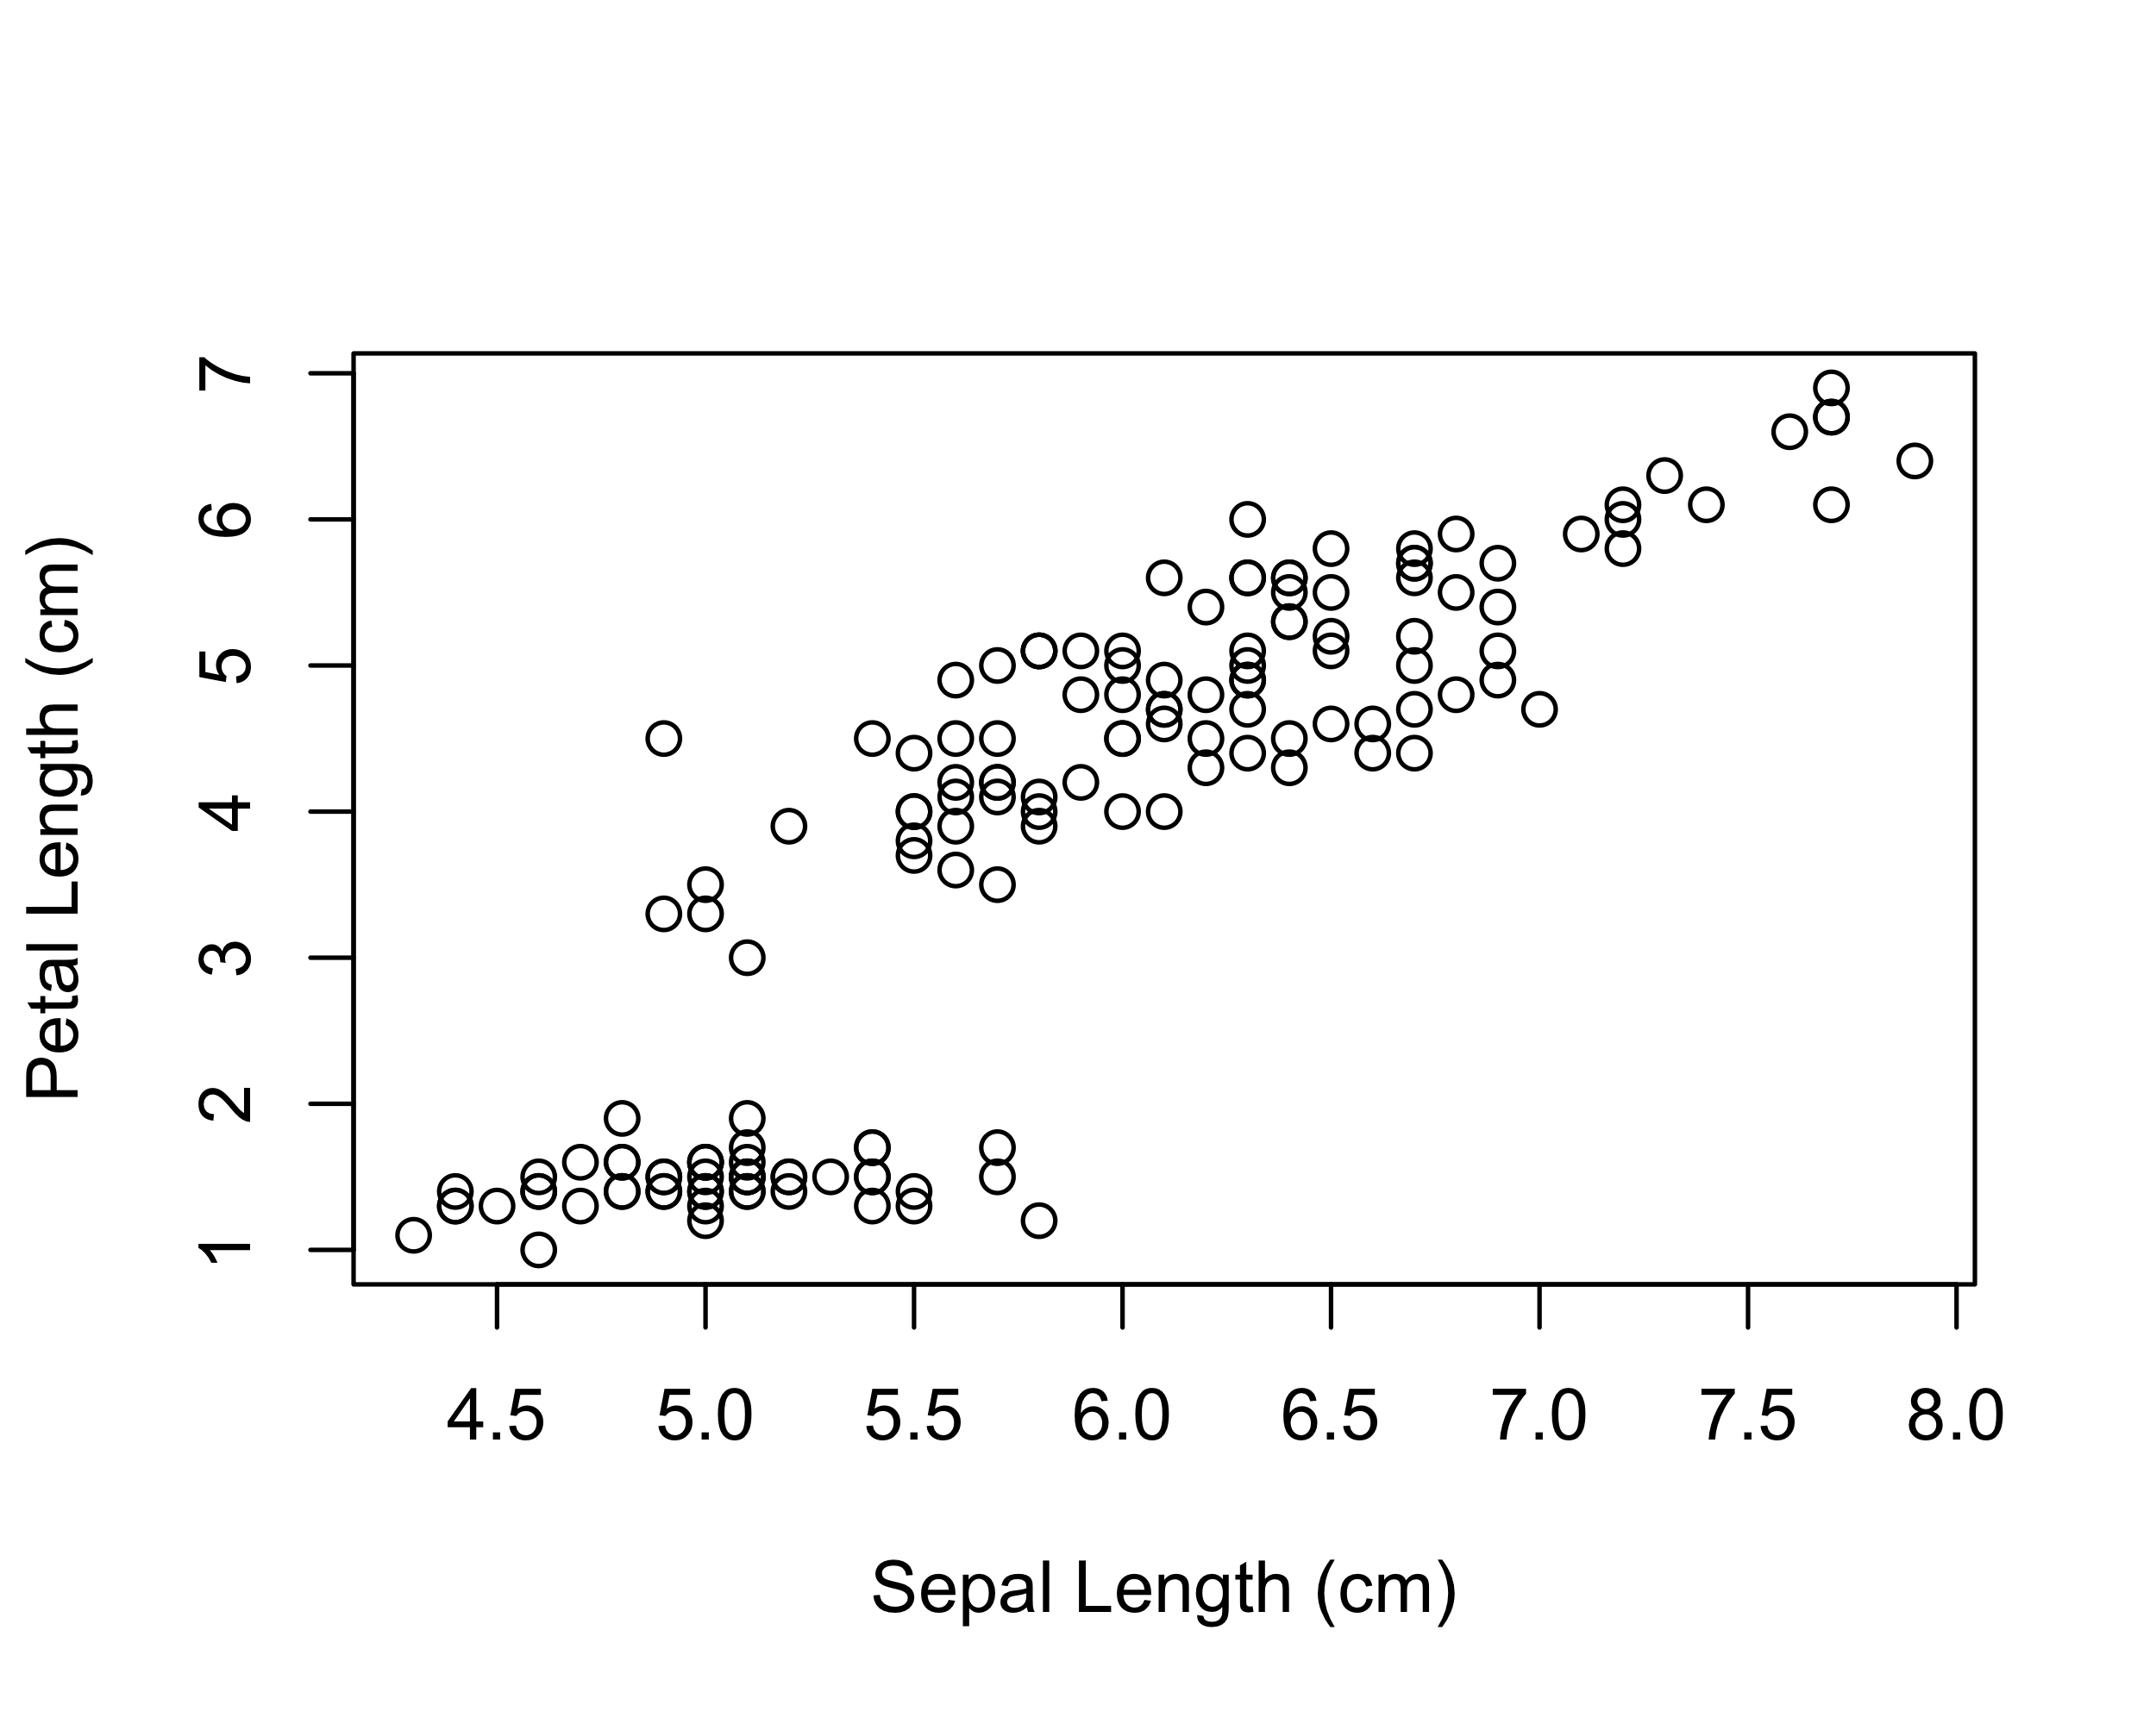

Figure-1: relationship between petal length (cm) and sepal length (cm)